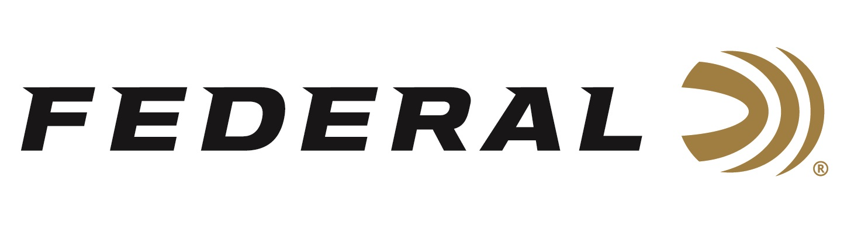

FOR IMMEDIATE RELEASE

Federal Premium Force X2 Wins the Best Ammunition Caliber Award for 2020 by NASGW-POMA

ANOKA, Minnesota – October 27, 2020 – Federal Premium Force X2 Personal Defense Shotgun Loads has been presented with the Caliber Award in the Best Ammunition New Product category by the National Association of Sporting Goods Wholesalers (NASGW), in partnership with the Professional Outdoor Media Association (POMA).

“We are thrilled to have won Best Ammunition for our Premium Force X2 at the 4th Annual NASGW-POMA Caliber Awards,” said Federal’s Vice President of Sales Jim Bruno. “The Caliber Awards are chosen by a dedicated group of wholesalers and media members who stay on top of product trends and innovations year after year. We know these individuals truly saw the value of all the features and benefits Force X2 delivers to any customer looking for the most innovative and effective personal defense load for shotguns. We are incredibly proud of this award.”

Force X2 utilizes nine copper-plated 00 buckshot pellets—specially engineered to split into two equal-size pieces on impact—to create up to 18 wound channels which improves the transfer of energy from the payload to the target and minimizes the potential for over-penetration, reducing the risk to bystanders. Force X2 is also loaded for more manageable recoil, allowing the shooter to stay on target for faster follow-up shots and better accuracy in a self-defense situation.

Federal Premium Hydra-Shok Deep 380 Auto was also a finalist for the NASGW-POMA Caliber Award in the Best Ammunition New Product category. This new Hydra-Shok Deep offering for 2020 is the first expanding 380 Auto load to consistently penetrate beyond the FBI-recommended 12-inch minimum. Like all Hydra-Shok Deep loads, its bullet’s more robust center post and core design ensure it penetrates to critical depths through common self-defense barriers, without over-penetrating.

Federal ammunition can be found at dealers nationwide or purchased online direct from Federal. For more information on all products from Federal or to shop online, visit www.federalpremium.com.

Press Release Contact: JJ Reich
Senior Manager – Press Relations
E-mail: VistaPressroom@VistaOutdoor.com

About Federal Ammunition
Federal, headquartered in Anoka, MN, is a brand of Vista Outdoor Inc., an outdoor sports and recreation company. From humble beginnings nestled among the lakes and woods of Minnesota, Federal Ammunition has evolved into one of the world's largest producers of sporting ammunition. Beginning in 1922, founding president, Charles L. Horn, paved the way for our success. Today, Federal carries on Horn's vision for quality products and service with the next generation of outdoorsmen and women. We maintain our position as experts in the science of ammunition production. Every day we manufacture products to enhance our customers' shooting experience while partnering with the conservation organizations that protect and support our outdoor heritage. We offer thousands of options in our Federal Premium and Federal® lines-it's what makes us the most complete ammunition company in the business and provides our customers with a choice no matter their pursuit.

